#### Yelp Application

This application allows users to search for businesses and users on Yelp, make friends with other users, and write reviews for businesses. It has a command line interface with a hierarchical menu.

#### Installation

To run the application, simply download the .py file and type “python Assignment7.py” in the terminal to directly run. After running the program, a message with log in name “s_ziyingp” and password will show as below.



#### Functions

##### **Login**

This function allows the user to log in to the interface to have access to all other functionalities. The user must enter a valid user ID. Here is a successful log in example of user with ID: __hr-GtD9qh8_sYSGTRqXw. After user successfully log in, the command line interface with functions menu will also show together. User can press 0 to 4 to choose different function.

Example shows below:

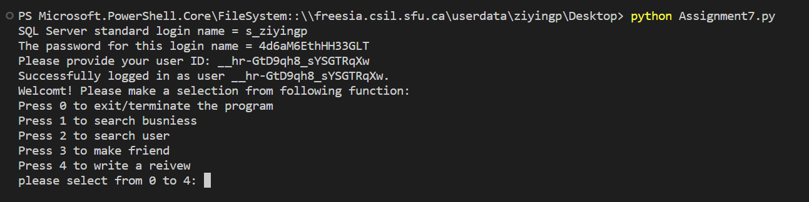

##### **Exit/terminate the program**

This function provided for user exit this program. User will log out the program when they choose “0”. Example shows below:

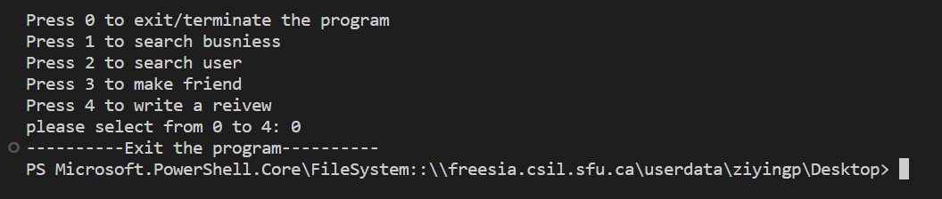

The program will keep user to log in until user press “0” to exist. (Or press CTRL+C)

##### **Search Business**

This function allows the user to search for businesses that satisfy certain criteria. User set the minimum and maximum number of stars, city, and name (or a part of the name) as their search criteria. After the search is complete, a list of search results will show on the terminal. The list must include the following information for each business: id, name, address, city, and number of stars. The results are ordered by name. Example shows below:

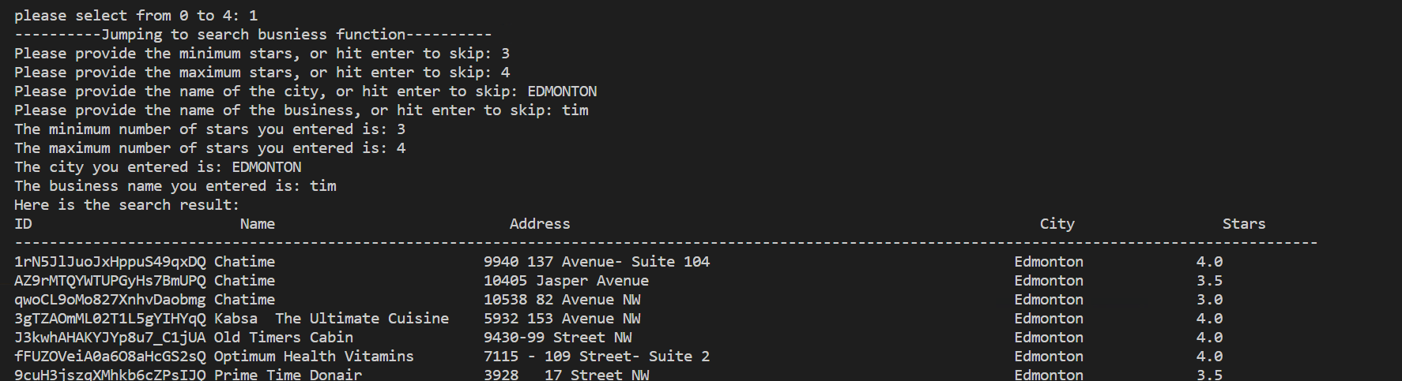

If the search result are empty, a message “----------Sorry, the search result is empty.----------” will show as below:

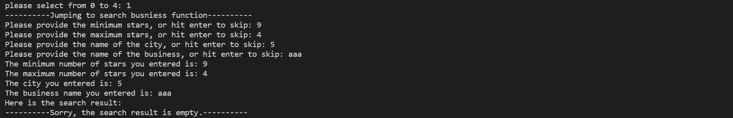

##### **Search Users**

This function allows the user to search for users that satisfy certain criteria. A user is able to set the following filters as their search criteria: name (or a part of the name), useful (yes/no), funny (yes/no), and cool (yes/no). The search is not case-sensitive. The user is considered useful, funny, or cool if they have a value greater than zero for the corresponding attribute. After the search is complete, a list of search results will be shown on the terminal. The list include the following information for each user: id, name, useful (yes/no), funny (yes/no), cool (yes/no), and the date when the user was registered at Yelp. Example shows below:

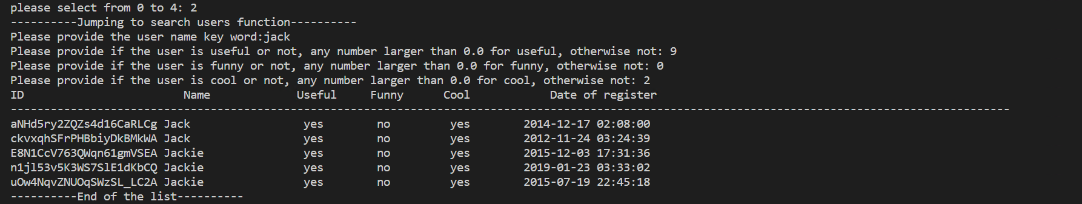

If the search result is empty, an message “----------Sorry, the search result is empty.----------” will be shown to the user.

##### **Make Friend**

A user must be able to select another user from the results of the function Search Users and create a friendship. After user enter the user’s ID in a terminal, the selected user will be a friend of the user that is logged in the interface. The friendship should be recorded in the Friendship table.

For this function here are three different cases shows below:

* Invalid user ID inputted: Message “----------Invalid user ID: Example of invalid user id input. Please enter a valid user ID.----------” will show as below:



* Two users have friendship already: Message “----------You guys already have friendship.----------” will show as below:

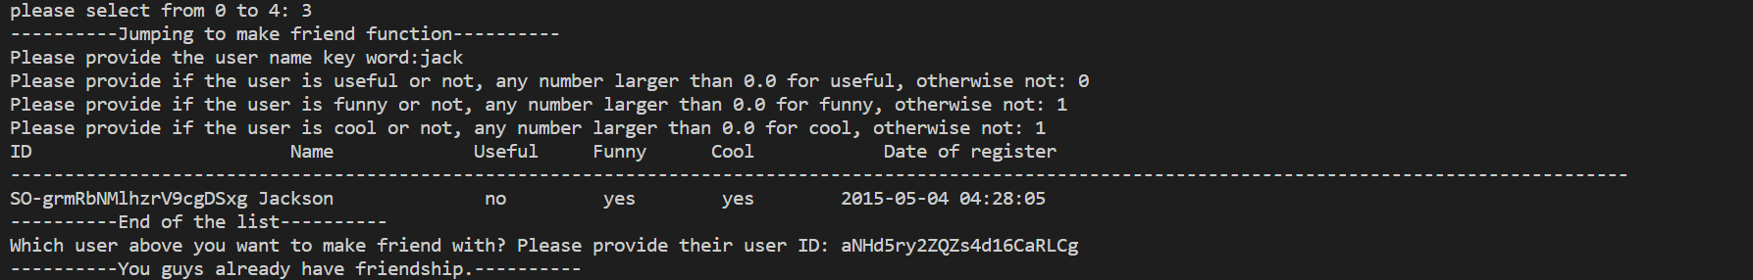

* Add friend successfully: Message “----------User with id: aNHd5ry2ZQZs4d16CaRLCg have become friend with you.----------” will show as below:

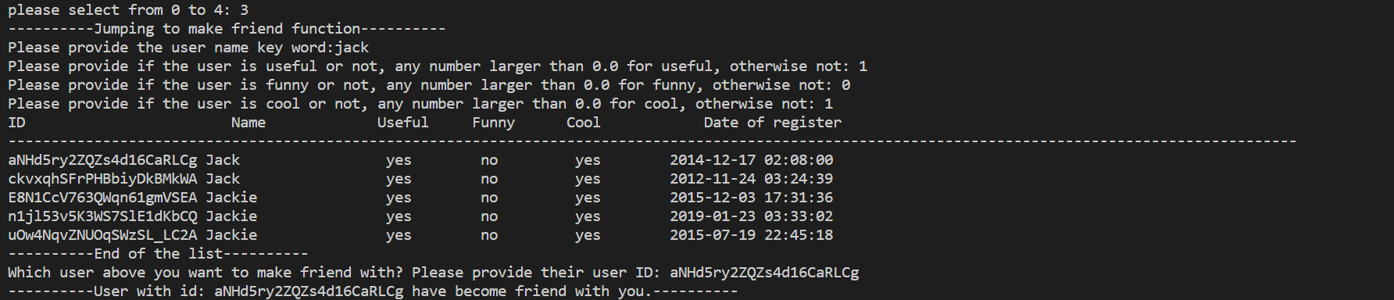

##### **Write Review**

A user should be able to write a review of a business. To write a review, a user must enter the business’s ID in a terminal. The user must provide the number of stars (integer between 1 and 5). After the review insert successfully, the message “----------Successfully insert the review----------” will show as below. The review will be recorded in the Review table, considering the ID of the logged user and the current date. The Review table will update as below(second screen shoot).



